**This kit is no longer for sale.**

**Engineer GFP Yeast**

# 

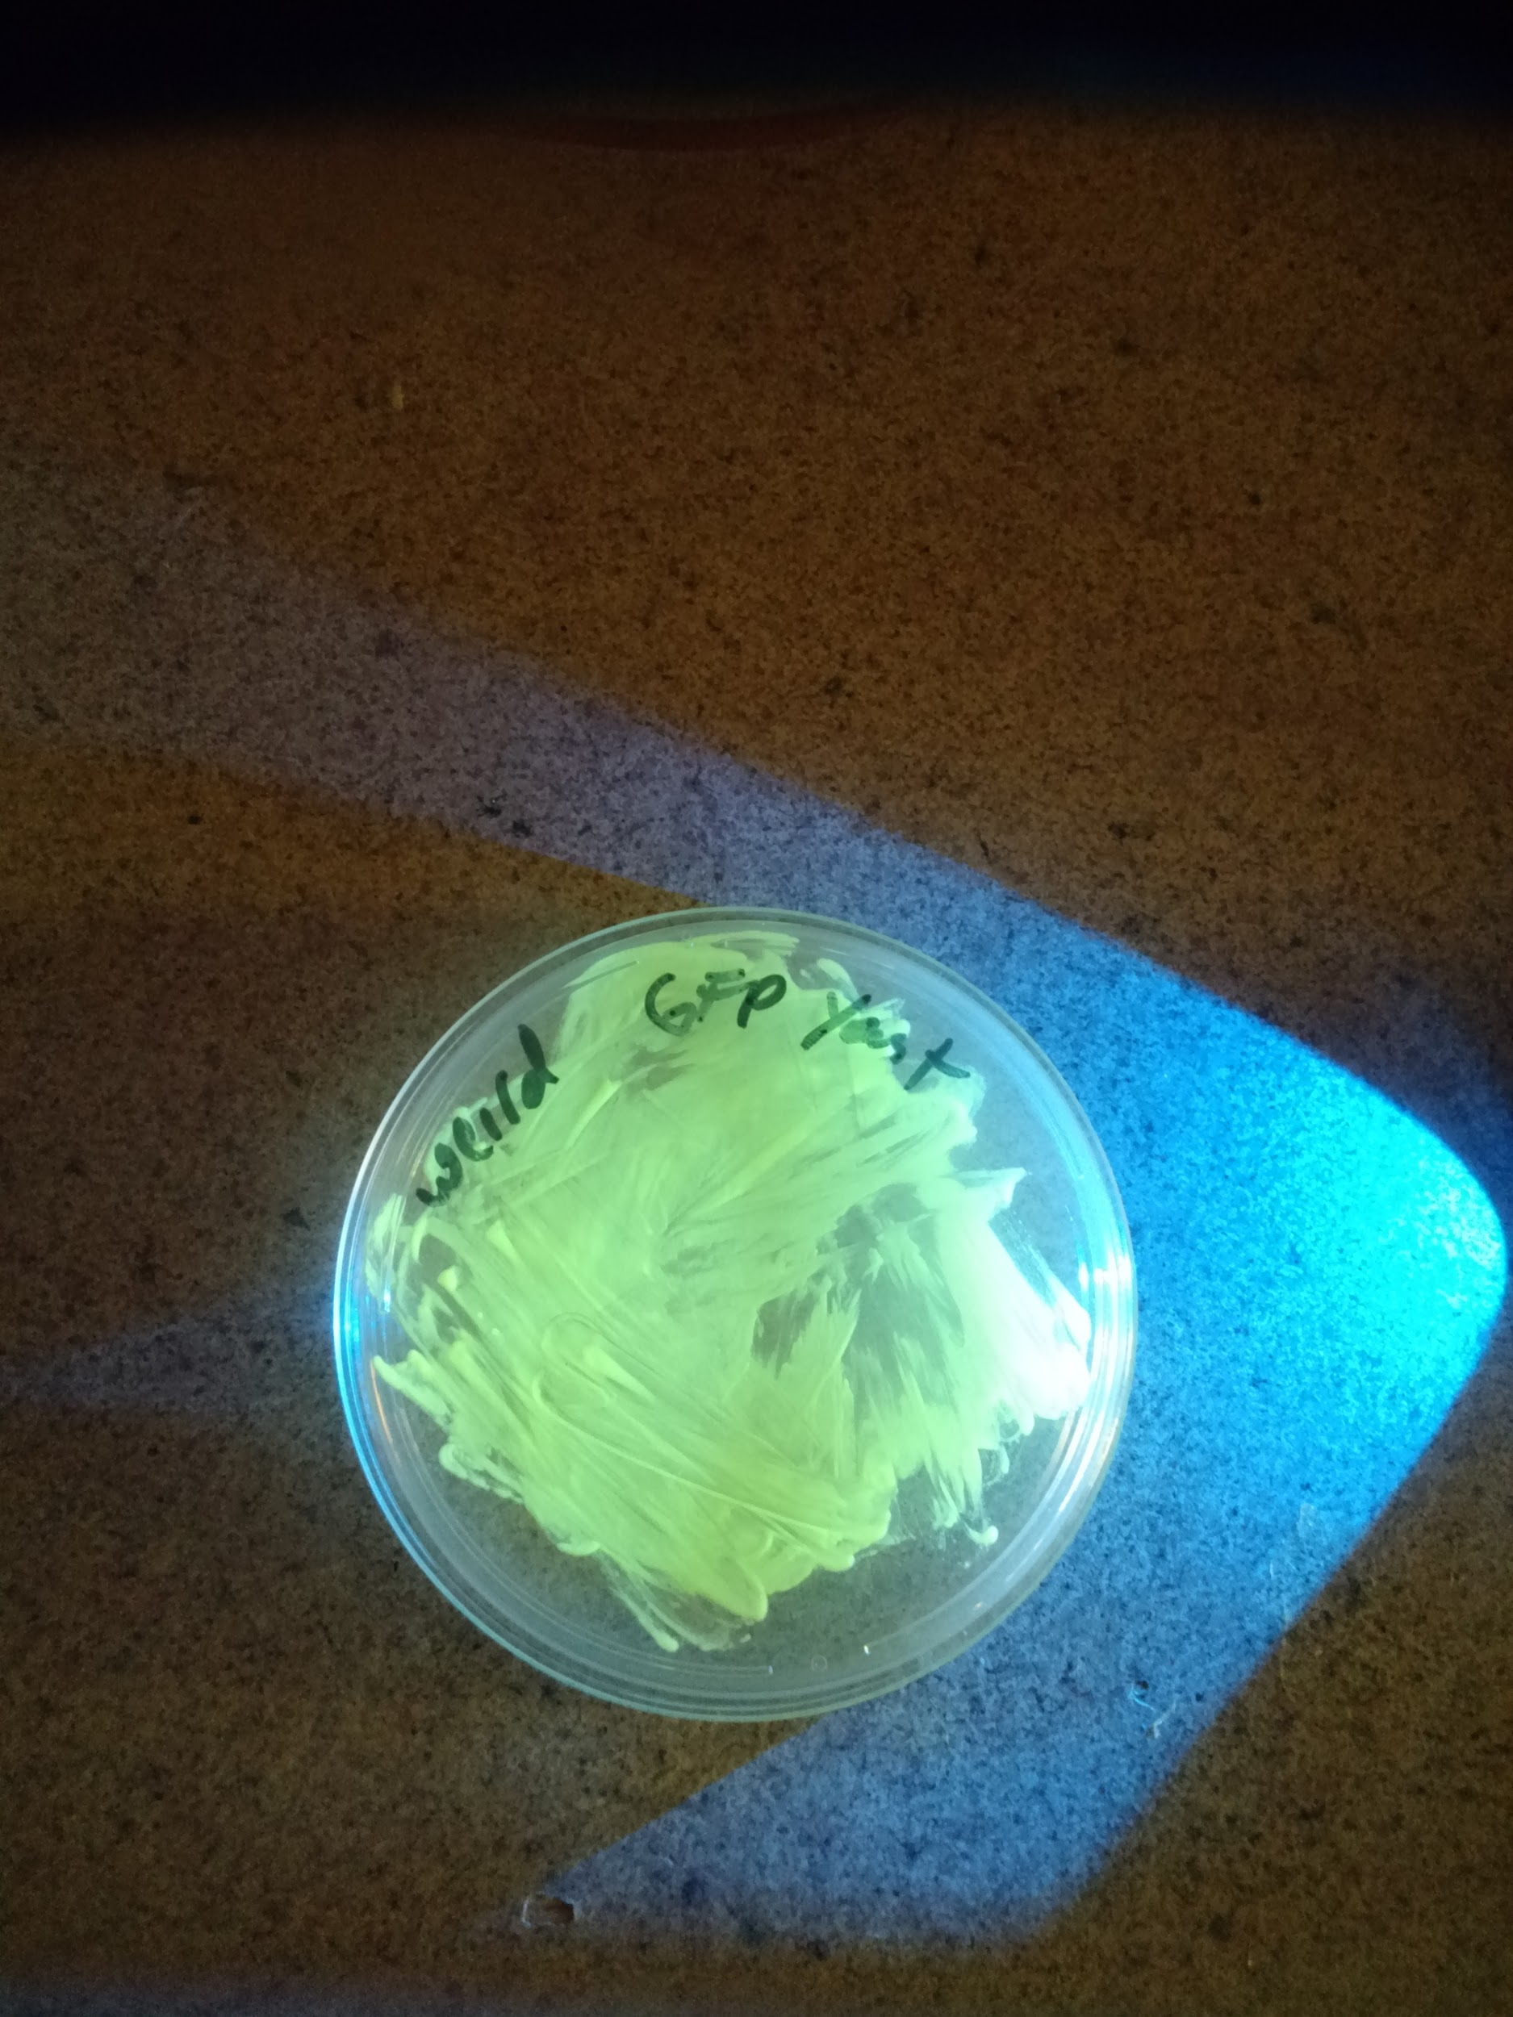

# 

# **Introduction:**

Genetic engineering involves modifying an organism’s DNA to deliberately change an aspect of the organism for a particular purpose. This kit demonstrates the power and simplicity of genetic engineering by adding plasmid DNA to the yeast *Saccharomyces cerevisiae* so that it turns a fluorescent green color from expression of the Green Fluorescent Protein (GFP).

This kit requires ~10 hours of work over the course of at least 2 days. It can be completed in a weekend if fresh Yeast cultures are prepared on a **Friday night**.

As this document is constantly being updated with tips and pointers and there are video links embedded, you can find the most up to date version online at: [http://goo.gl/YBfYuQ](https://drive.google.com/open?id=1-qHlXZbTdXyjojd8VA8czqWei58zOg6RiRudguJiPog)

# **What is happening in this experiment?**

Yeast and all organisms need to make proteins to survive. Proteins are tiny nanomachines that do everything from control our metabolism to keeping our heart beating. In order to make a protein a cell uses the DNA code. Each 3 letters of DNA codes for a single amino acid and proteins are just chains of amino acids.

Proteins (like GFP) are made by a nucleic acid and protein complex in the cell called the [ribosome](https://en.wikipedia.org/wiki/Ribosome).

The yeast before the transformation lacks the DNA to make the protein that makes Uracil, a monomer of RNA. The DNA you are putting in the yeast, besides giving instructions to make GFP, it also has the DNA to restore the yeast's ability to make its own Uracil. The media you will plate the transformation on has no Uracil, -Ura, so only yeast cells that accepted the DNA in the transformation should grow.

# Protocoldisplaybottom.png

# protocoltableofcontents.png

# Kit contents(pg. 4)

# Timeline(pg. 5)

# Making Plates[(pg. 6/7/8)](https://docs.google.com/document/d/1JMZmCDhzAtN2FSrjAbxP_FhRK90XbYpE0_PDvRYAKIQ/edit#heading=h.ekponrotise2)

# Making Competent Yeast[(pg. 9/10)](https://docs.google.com/document/d/1JMZmCDhzAtN2FSrjAbxP_FhRK90XbYpE0_PDvRYAKIQ/edit#heading=h.ekponrotise2)

# DNA Transformation[(pg.11)](https://docs.google.com/document/d/1JMZmCDhzAtN2FSrjAbxP_FhRK90XbYpE0_PDvRYAKIQ/edit#heading=h.ekponrotise2)

# Successful experiment example[(pg. 12)](https://docs.google.com/document/d/1JMZmCDhzAtN2FSrjAbxP_FhRK90XbYpE0_PDvRYAKIQ/edit#heading=h.ekponrotise2)

Protocoldisplaybottom.png



1 - YPD Agar (~6g in a 15mL tube to mix with 150mL water)

1 - CM, -Ura Agar (~6g in a 15mL tube to mix with 150mL water)

1 - 250 mL glass bottle for pouring plates (fill with 150mL water)

1 - 10-100uL variable volume adjustable pipette (1uL increments)

1 - Box (96 count) 1-200uL Pipette Tips

14 - Petri Plates

1 - Microcentrifuge tube rack

5 - Inoculation Loops / Plate spreader / Pairs of Nitrile Gloves in plastic bag

25~ - microcentrifuge tubes

6 - 1.5mL microfuge tubes containing .03g YPD

50mL centrifuge tube for measuring liquid volume

1 mL Yeast transformation buffer 40% PEG 8000, 200mM LiAc, 0.1mg/mL Salmon Sperm DNA

**Perishables**

S. cerevisiae French Saison strain

Yeast GFP Expression plasmid 100ng/uL

Protocoldisplaybottom.png



**Preparation**

* 1 hour Make plates (set aside more time if it's your first time making plates)
* streak out Yeast onto a YPD Agar plate (takes ~1 min)
* 12-18 hours Let the yeast grow (easiest to just let it sit overnight)

**Day of experiment**

* Mix together sample, plasmids, and transformation mix (takes ~5 min)
* **60 min** ‘heat shock’ the sample warm (42ºC/108ºF) water.
* Add YPD media to your cell solution (takes ~1 min)
* **4 hour** incubate at 30C, (or if @ room temp, incubate overnight)
* **10 min** Plate 100uL of the yeast solution and let dry for 10 minutes

**Incubate and wait for growth**

* ~48 hours Incubate the plate at 30ºC (80ºF) for 24-48 hours or room temperature for 48+

hours.

**Protocoldisplaybottom.png**

# **protocolandwalkthrough.png**

# **Making Plates (~1 hour, maybe more time if it’s your first time)**

Step by step walk-through with photos at:<https://goo.gl/7yzpA1>

Agar plates provide a solid media nutrient source for yeast to grow on. The standard media that is used is Y(E)PD (Yeast Extract, Peptone, Dextrose). This contains a carbon source, a nitrogen source. Strains of that are used in genetic engineering are also what are called [auxotrophic](https://en.wikipedia.org/wiki/Auxotrophy) meaning that they can’t synthesize certain things that they need for survival.

The top part of the full plate has the larger diameter.

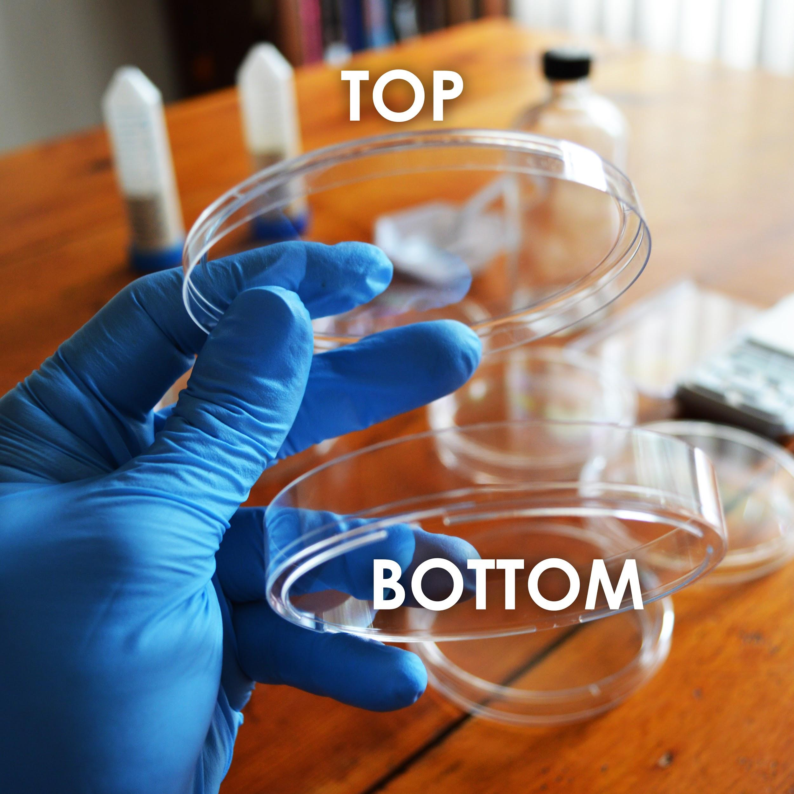

Protocoldisplaybottom.png

**Making Plates**

1. First you will prepare the solid media to for your yeast to grow on. Make sure to label the bottom dish with the type of media, as the media look the same once prepared. Find the tube labeled “YPD Agar Media.”Take a tube labelled Agar media, such as “YPD Agar Media”, “CM Minus Uracil Agar Media” or similar Dump its contents into the 250mL glass bottle. (You will need to make plates out of each kind of media, so start with whichever tube of media you choose.)
2. Using the 50mL conical tube labelled “For Measuring Liquid”, measure and add 150mL of water to the glass bottle.
3. Making agar is like making jello-- heat the agar to dissolve it, then it will solidify when it cools. Heat the bottle in the microwave for 30 seconds at a time, being careful not to let the bottle boil over. DO NOT SCREW THE LID DOWN TIGHT! (just place it on top and give it a slight turn)
4. You will know it’s done when the liquid looks yellow and fully see-through (no fogginess). This should take about 2 -3 minutes total of microwaving. Take the bottle out(caution contents hot) and let it cool until you are able to touch it without much discomfort. This will take 20-30 minutes.
5. While the bottle remains somewhat warm, pour the plates. One at a time, remove the lid of 7 plates and pour just enough of the LB agar from the bottle to cover the bottom half of the plate. Put the lid back on.

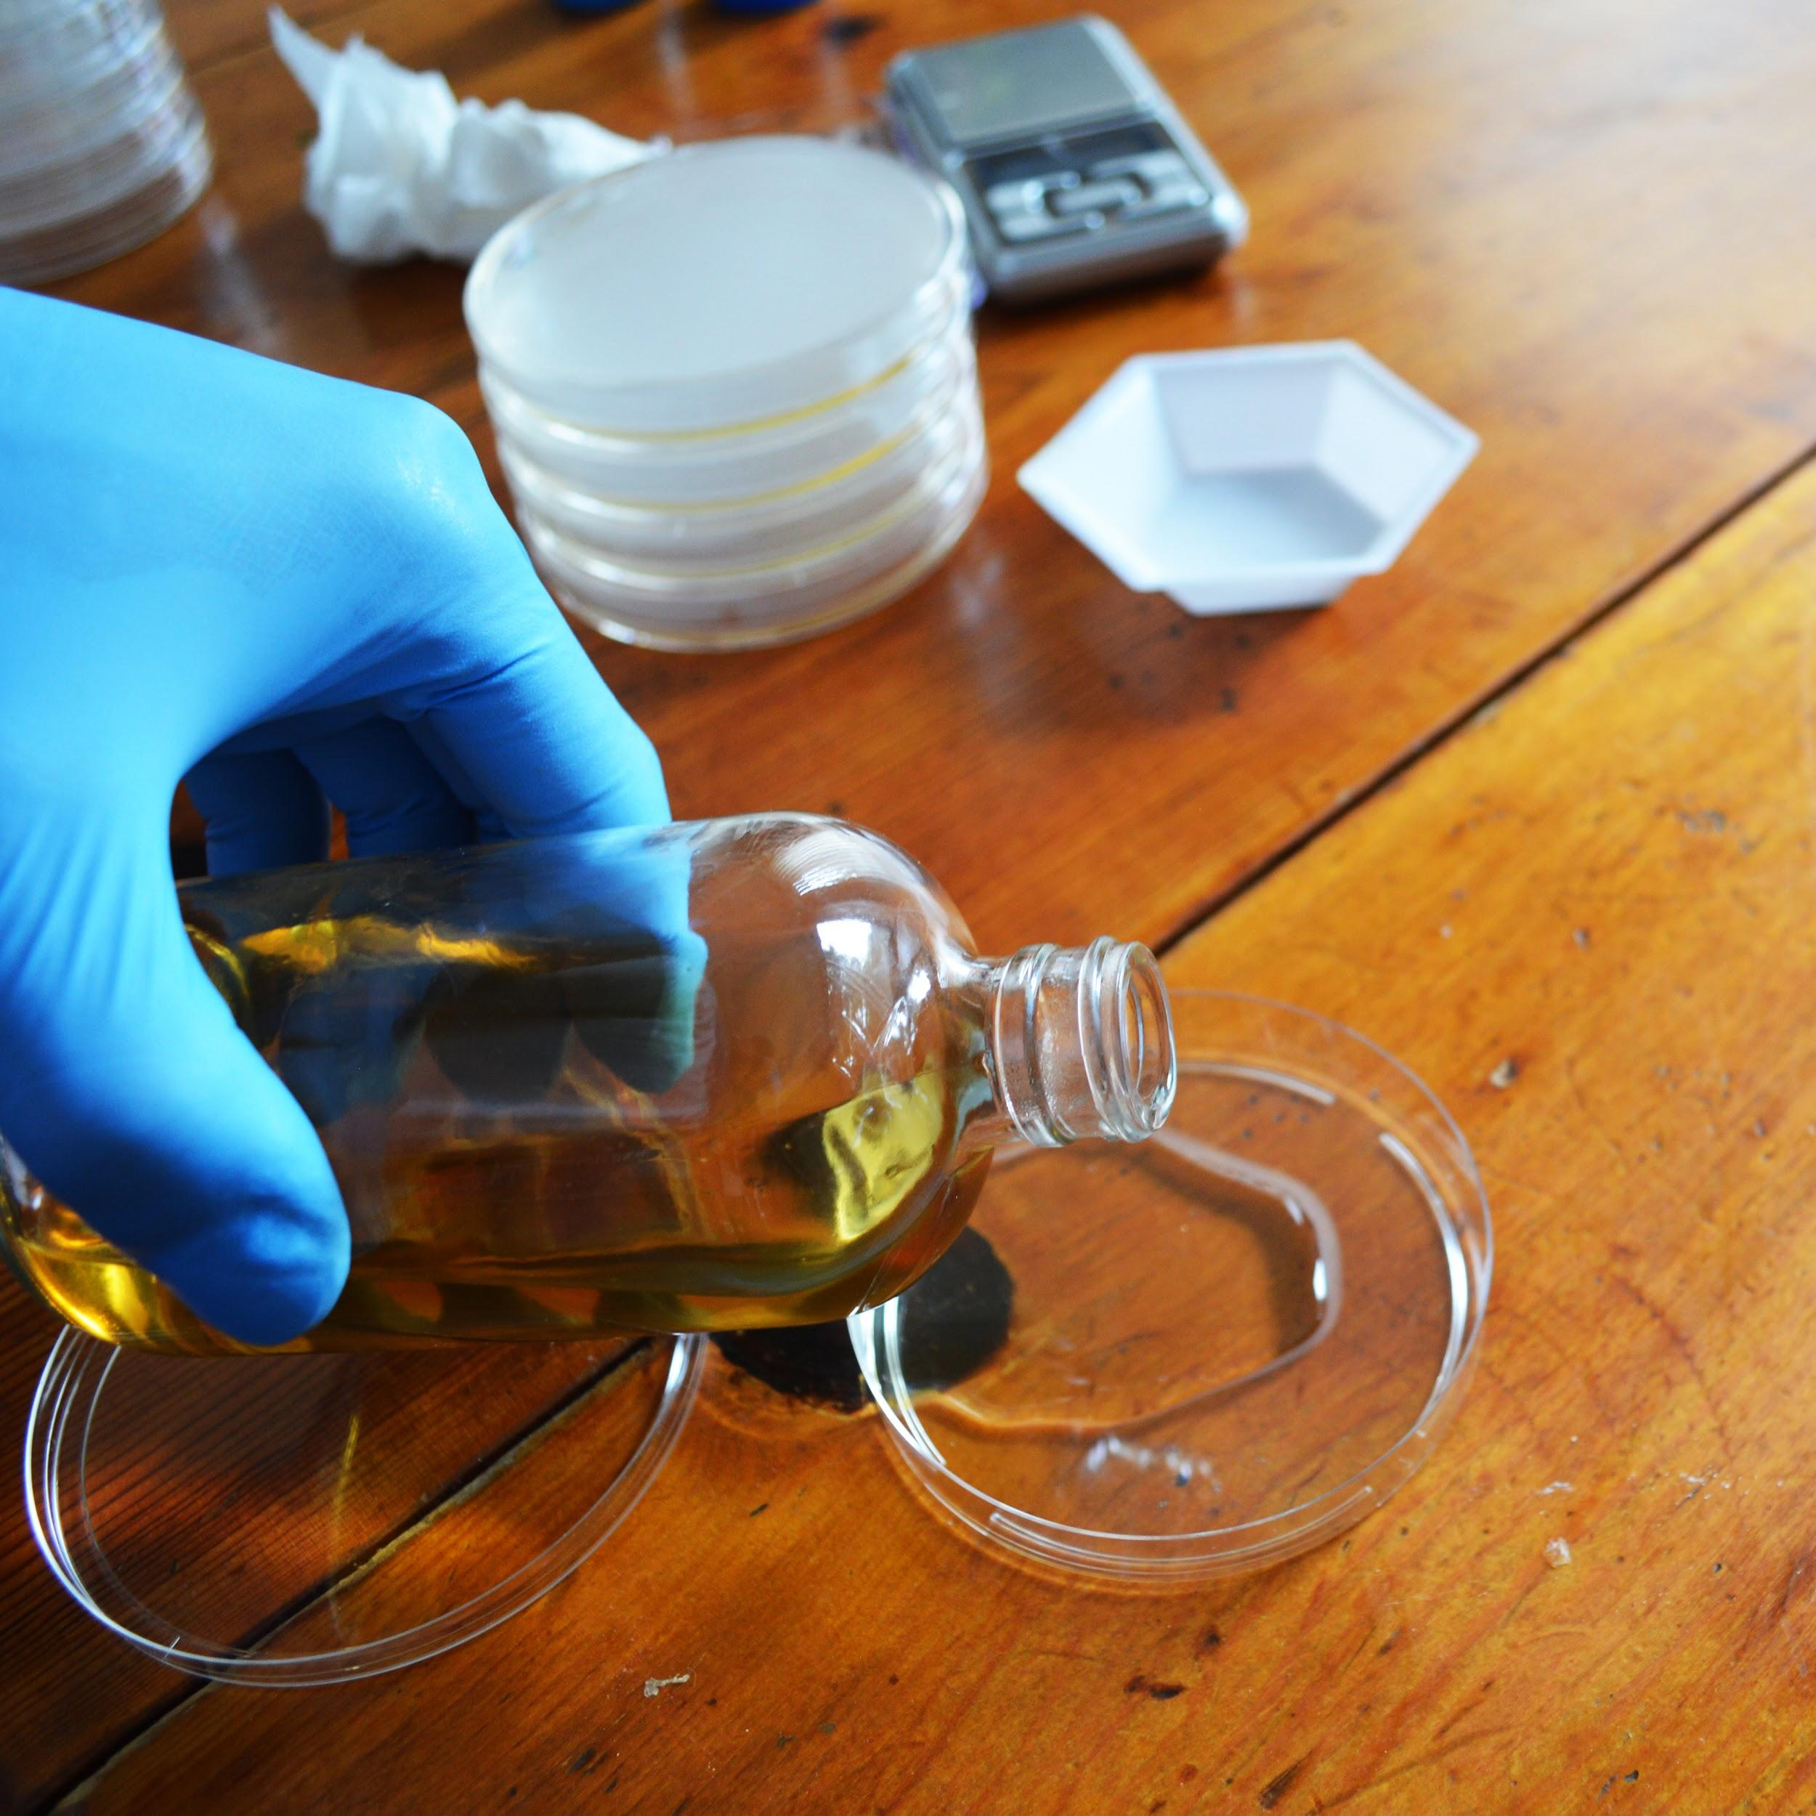

Protocoldisplaybottom.png



**Making Plates**

1. Let cool for at least one 1 hour before use(you can cool faster by putting them in the fridge but don’t freeze). If possible let the plates sit out for a couple hours or overnight to let the condensation evaporate. Then store in your fridge at 4ºC upside down so any condensation doesn’t drip on the plates.

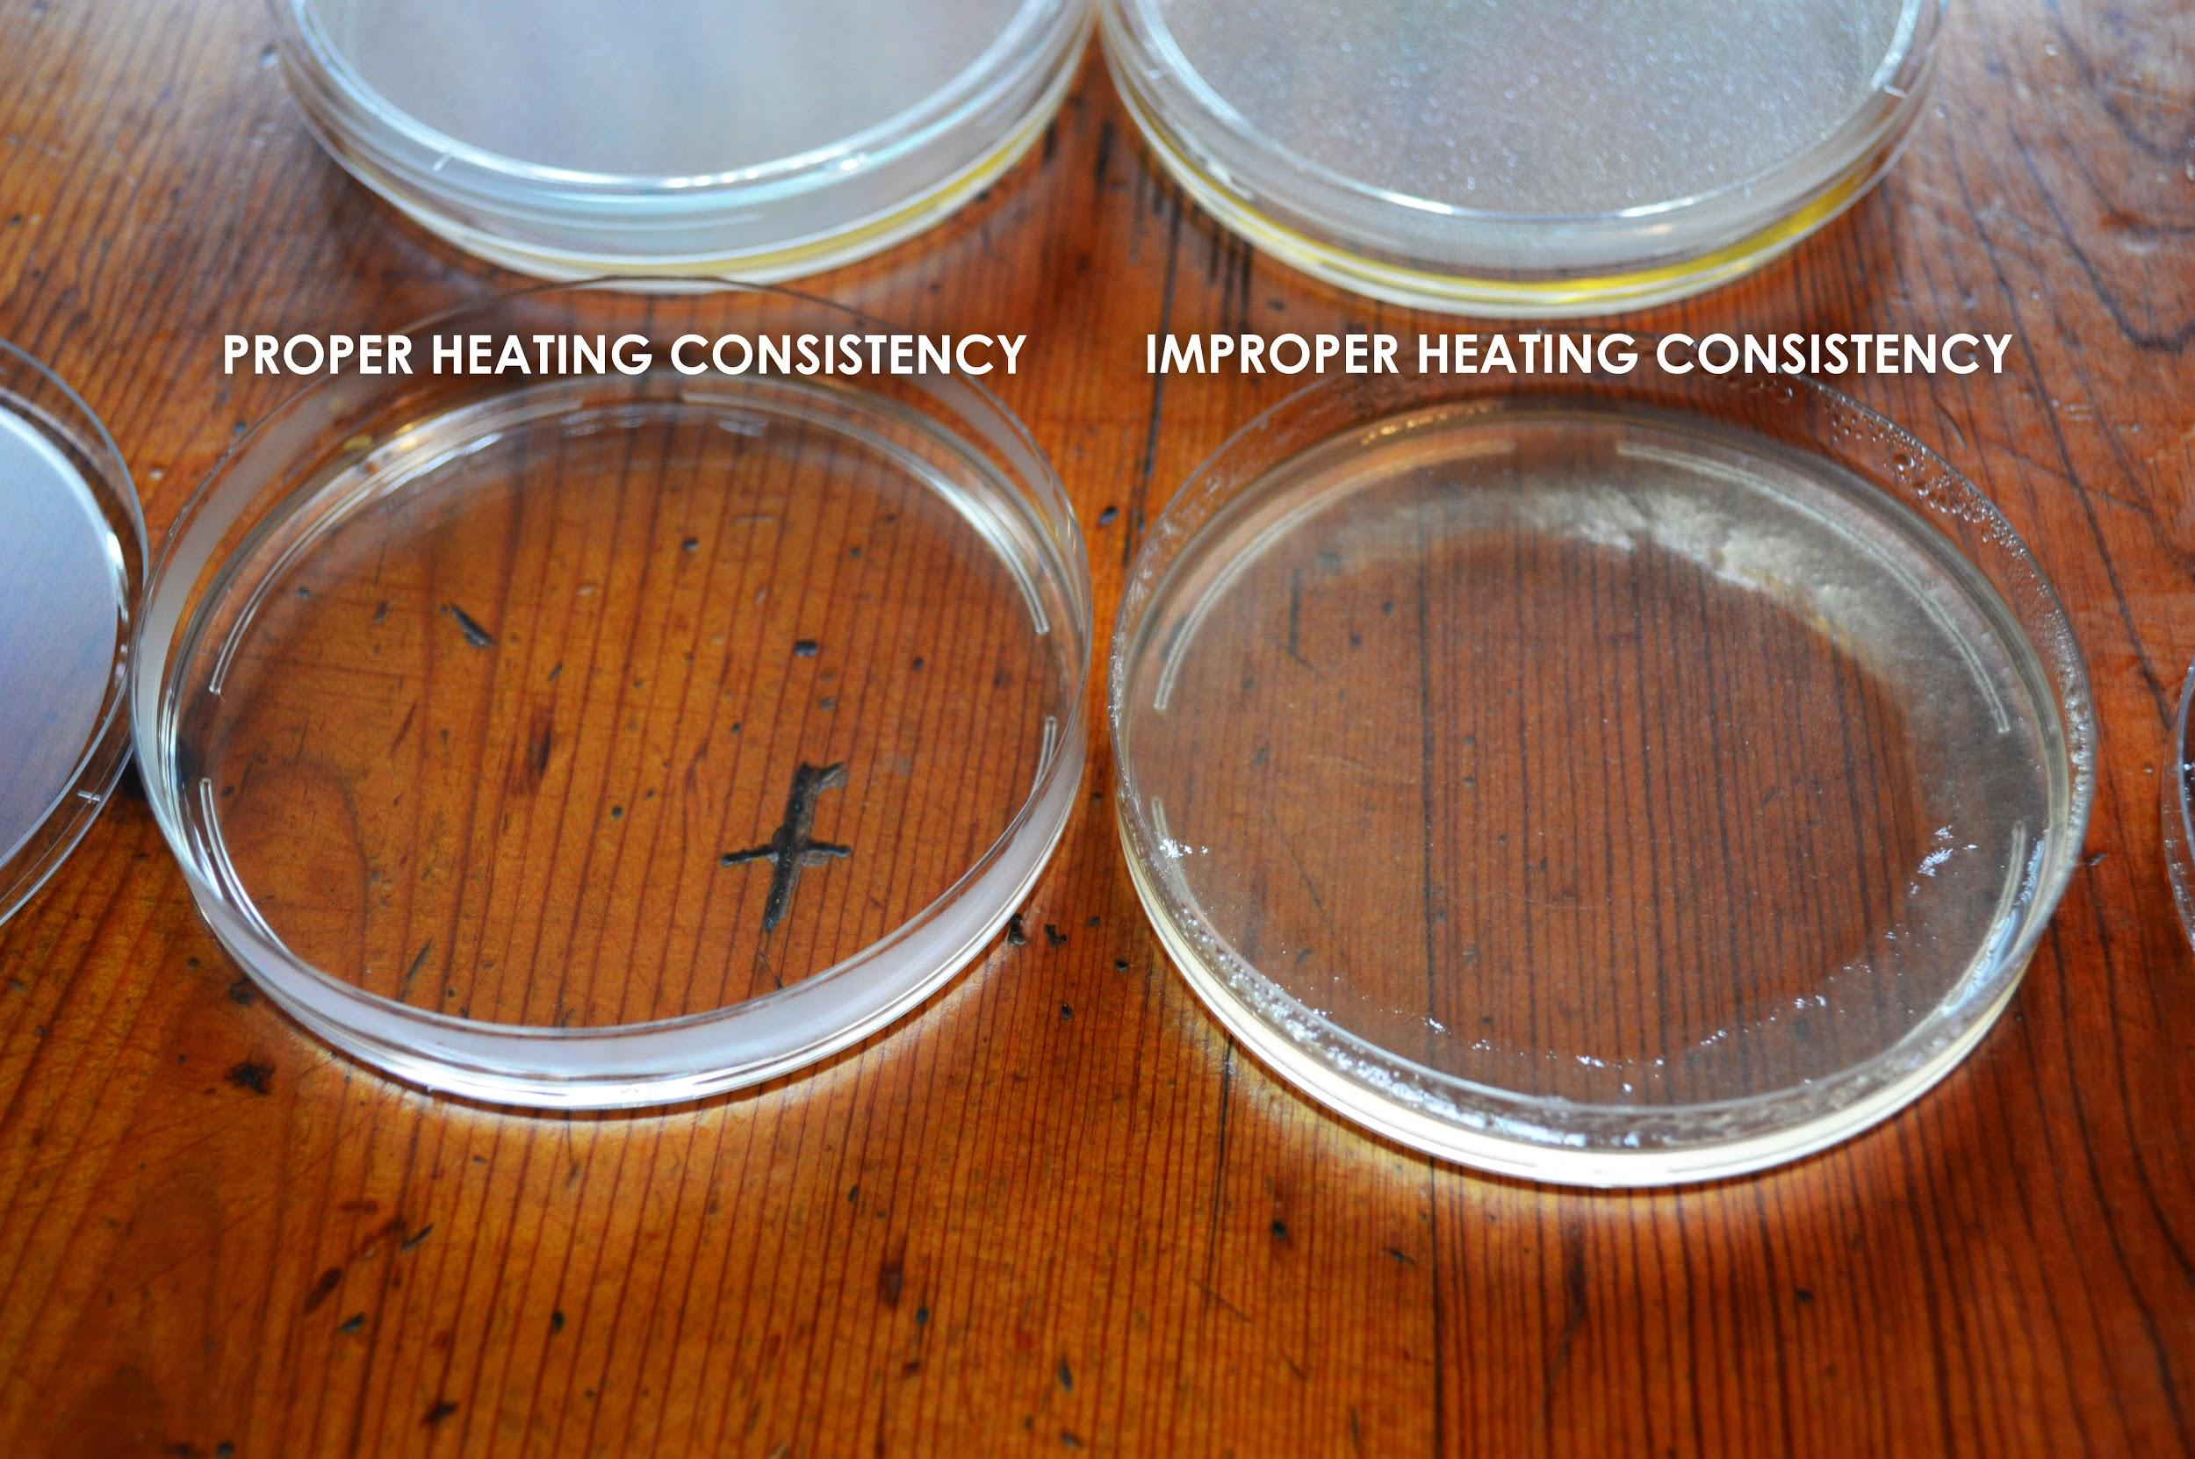

## 

Protocoldisplaybottom.png

## **protocolandwalkthrough.png**

## **Making Competent Yeast Cells for Transformation**

‘Competent’ means the yeast are able to take in foreign DNA. The cell walls *normally* prevent things from entering in, but we are going to mix the yeast with chemicals and salts that change this. In order to get GFP DNA to work inside the yeast cells we need to get all of the components inside the cells! This process is called transformation. We put all the materials into synthetic DNA and then trick the Yeast into thinking that our DNA is its own DNA and so they make Green Fluorescent Protein..

The yeast transformation mix contains:

**40% Polyethylene Glycol(PEG) 8000**

PEG is thought to play a number of roles in transformation: from shielding the charged DNA, to helping it get into the cell, to making the cell membrane more porous.

**100mM Lithium Acetate(LiAc)**

LiAc is thought to shield and neutralize the negative charge of DNA to make it more likely to enter into the cell.

**Single Stranded (SS) Carrier DNA**

SS Carrier DNA is known to help DNA enter into yeast during the transformation process. It is thought to prevent nucleases from digesting the plasmid and also bind to the yeast cell membrane making it easier for the plasmid DNA to enter the cell.

1. Take one of the tubes of dried *S. cerevisiae*4 French Saison, add water to the top and shake till it is all dissolved. Next, using your pipette put 100uL of the yeast solution onto a new YPD agar plate you made and using an inoculation loop gently spread or “streak” the yeast. Let the plate grow overnight ~12-18 hours, or until you see white-ish yeast begin to grow. Make sure you are using the YPD agar plate, NOT the CM -URA agar plate. See the following link for a walk-through of how to streak out yeast:<https://goo.gl/GR8IOf>
2. Add 100 microliters(μL) of Yeast Transformation mix to a new microcentrifuge tube. If you have never used a pipette before [you can find a guide here](https://drive.google.com/open?id=1e9heRklEyINMc_sHPyRcBB3mxT0vnf4wqxkn7aiwlBM)

Protocoldisplaybottom.png

## **protocolandwalkthrough.png**

1. Using an inoculation loop, gently scrape some yeast off of your fresh plate, about the area of a pencil eraser, and mix it into the transformation mix. Be gentle! The agar is soft. Mix until any big clumps have disappeared. This might require gently pipetting the mixture up and down.

Avoid creating bubbles if possible.

1. Make one tube for each genetic engineering experiment you plan to perform in the next day or two and store them at 4ºC (39ºF) in the fridge. Remember you don’t need to do it all at once.

## **Making Competent Cells for Transformation(continued)**

1. Pipette 100uL of Transformation mix to a new microcentrifuge tube. See the following link to learn to pipette:<https://goo.gl/nrA8hT>
2. Using an inoculation loop, gently scrape some yeast off of your fresh plate and mix it into the transformation mix. Mix until any big clumps have disappeared. This might require gently pipetting the mixture up and down. Avoid creating bubbles if possible. Your transformation mix should be very cloudy, if not mix in more yeast till you cannot easily see through the liquid in the tube. Make one tube for each GFP experiment you plan to perform in the next day or two and store them at 4ºC (39ºF) in the fridge.

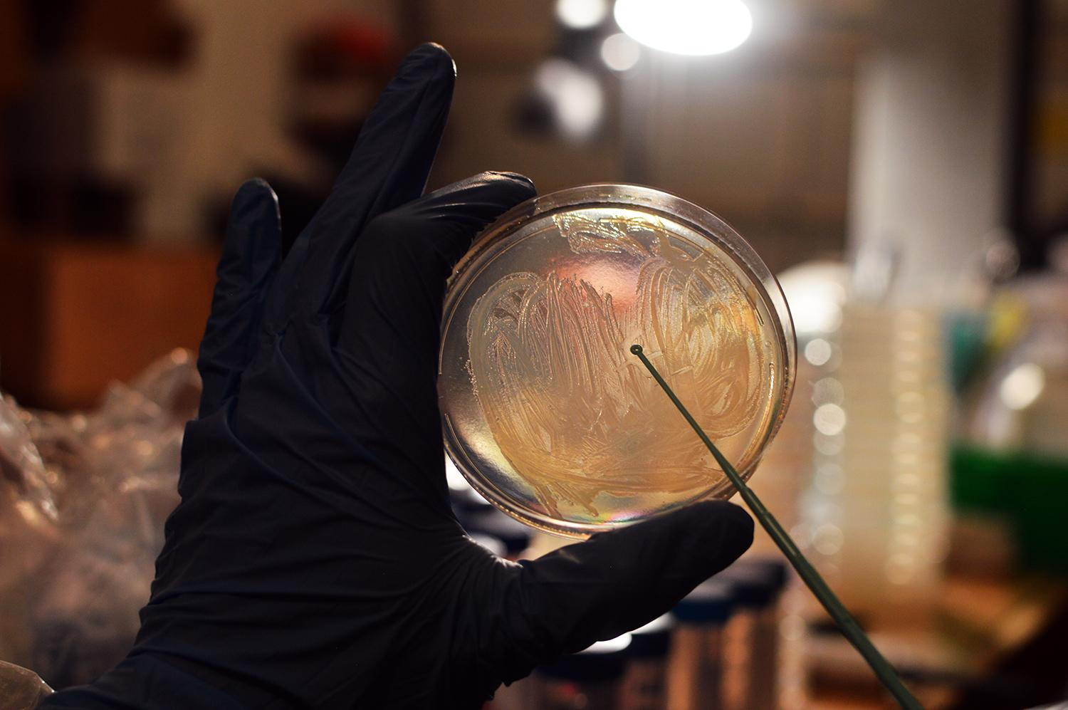

Protocoldisplaybottom.png



1. Find the DNA tube labelled “Yeast GFP Plasmid” and using your pipette add 10 microliters(μL) to your competent cell mixture. Change pipette tips.
2. Incubate the tube for 1 hour in ~42ºC (108ºF) water. You can approximate this temperature by using water that is warm, but comfortable enough such that you can still keep you hand in it.
3. Add 1.5 milliliters (mL) of room temperature water to one of the YPD media microcentrifuge tubes and shake to dissolve the YPD.
4. Using the pipette, add 900μL of YPD media to your competent cell mixture containing your DNA.
5. Incubate the tube at 30ºC(86ºF) for 1 hours or 4 hours at room temperature. This step allows to yeast to recover and replicate the DNA. If you want to incubate longer it can help improve the efficiency of the transformation.
6. Take a CM minus URA plate out of the fridge and let it warm up to room temperature. Using the pipette, add 300μL of your transformation mixture on top of an CM -URA Agar plate.
7. Using an inoculation loop or plate spreader gently spread the yeast around the plate and let dry for 10 minutes before putting the lid back on.
8. Flip the plate upside down to prevent condensation from forming and dripping onto your yeast.
9. Incubate the plate at 30ºC (86ºF) for 1-3 days or room temperature for 2-4 days or until you start to see yeast growing as little white dots.
10. Put on your special yellow glasses and shine the blue light on the plate. If the yeast were engineered properly they should glow green! Sometimes the yeast with look green even without the light and glasses.
11. If not, give it another shot, Science doesn’t always work on the first try. Also, feel free to contact us at [odin@the-odin.com](mailto:odin@the-odin.com) and we will help you troubleshoot.

## **Protocoldisplaybottom.png**



## **Successful experiment example...**

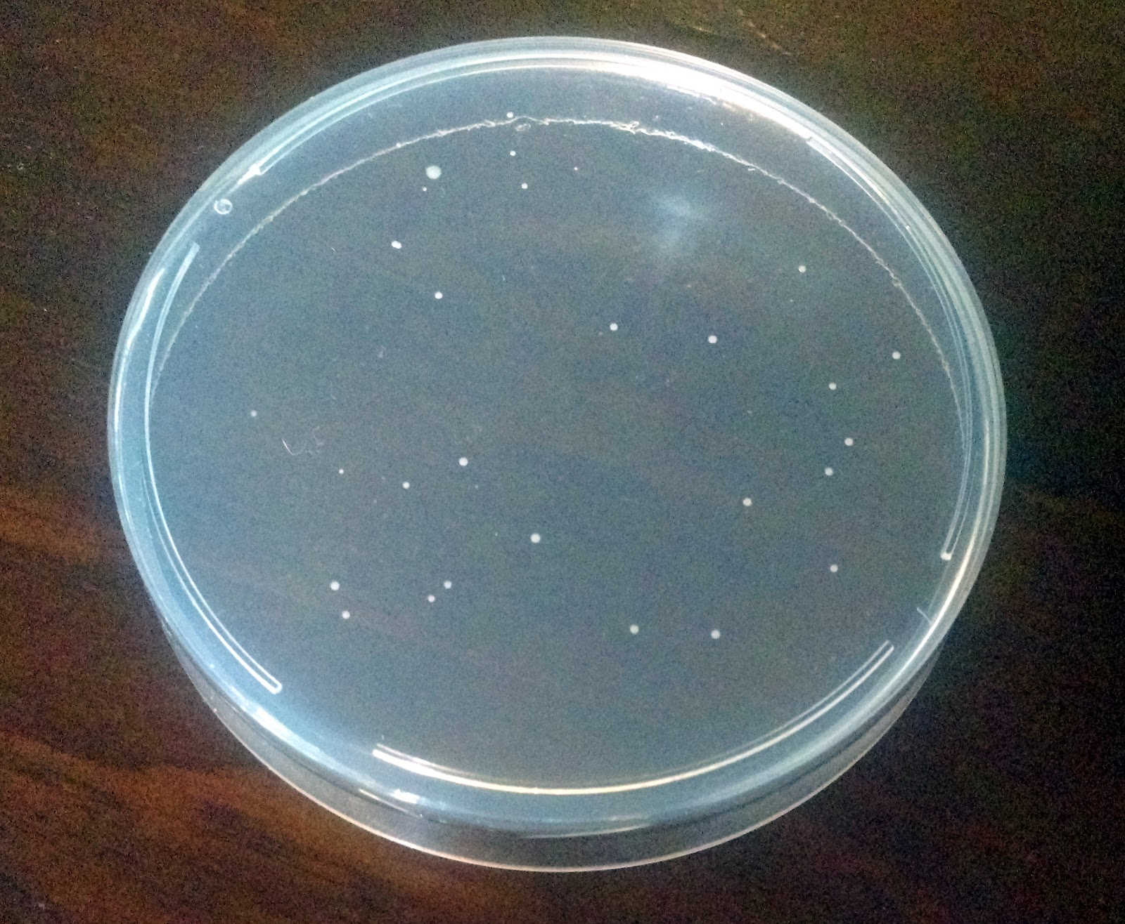

In a successful experiment you should see yeast growing on the plate as seen in the picture. By shining the blue LED light on these colonies, while wearing your cool yellow shades, the yeast will be bright fluorescent green! These are yeast colonies that were successfully took up the DNA and so they survived and replicate to form what Scientists call colonies, or small groups of yeast.

Protocoldisplaybottom.png